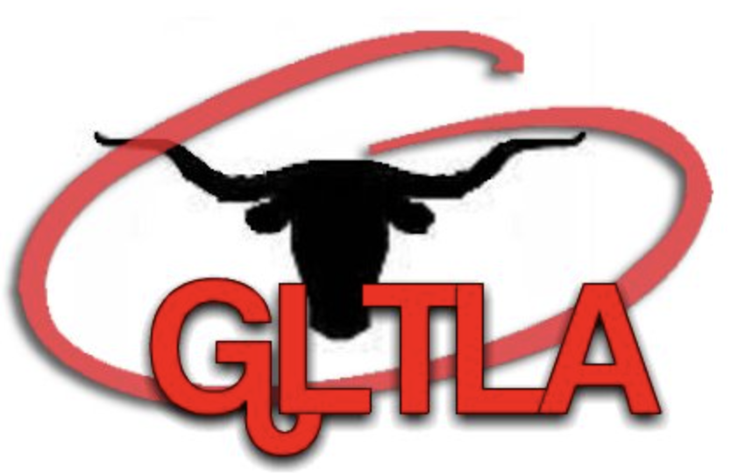
GREAT LAKES
TEXAS LONGHORN ASSOCIATION
SPONSORSHIP PACKAGES

$500 Platinum Sponsor
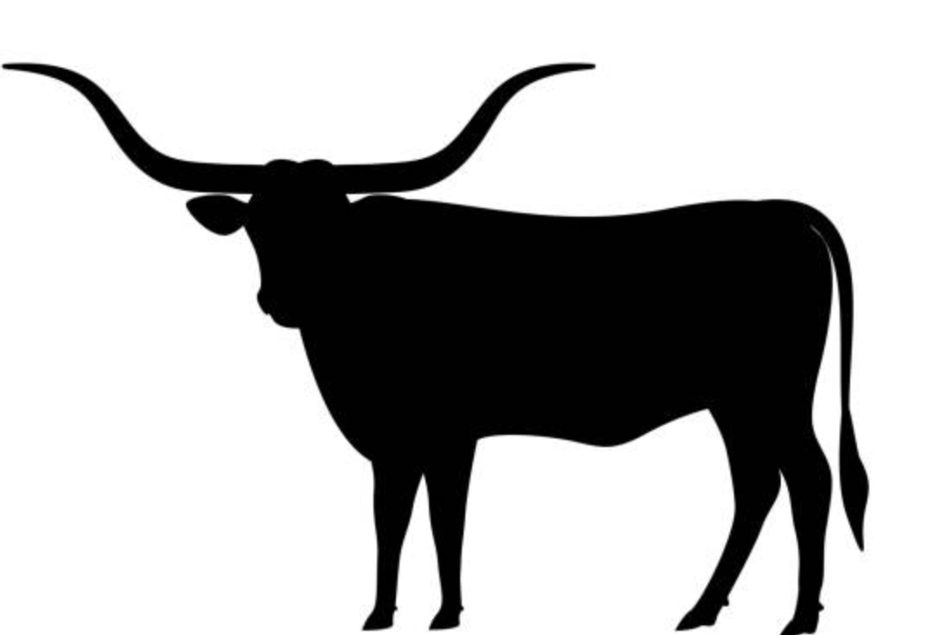
- Custom individual business banner displayed in the show arena.
- Photo of business logo on GLTLA website.
- Full individual business page in showbook. ( Graphics must be provided.)
- Social media post with business contact information
- Business name on back of GLTLA shirts

$250 Gold Sponsor
- Custom individual business banner displayed in the show arena.
- Photograph of business logo on GLTLA Website.
- Social media post with business contact information.
- Business listed in showbook as sponsor.

$100 Silver Sponsor
- Name listed on the general sponsor show banner.
- Photograph of business logo on GLTLA Website.
- Social media post with business contact information.
- Business listed in showbook as sponsor.

GREAT LAKES
TEXAS LONGHORN ASSOCIATION
SPONSORSHIP
Business: _______________
Name:__________________
Address:_________________
Phone Number:____________
Sponsorship Type:
- Platinum ($500)
- Gold ($250)
- Silver ($100)

- All Sponsors are welcome to partake in weekend festivities.
- All sponsors who show a copy of their sponsorship form will be given a free GLTLA T-Shirt.

